CIS37A Class Project Due Date: July-26-2017

The following is the program that you should complete for the course project. You have the remaining weeks of this course to complete this project.

You must also write a lab report that contains:

Introduction: A one page writing the describes the game and how your program solves this problem.

Body: contains the code (well commented) and code descriptions.

Conclusion: What have you learned in this project, your approach of solving and debugging the code, future enhancements.

Extra credit for the project: you may add graphics for the cards for extra credit.

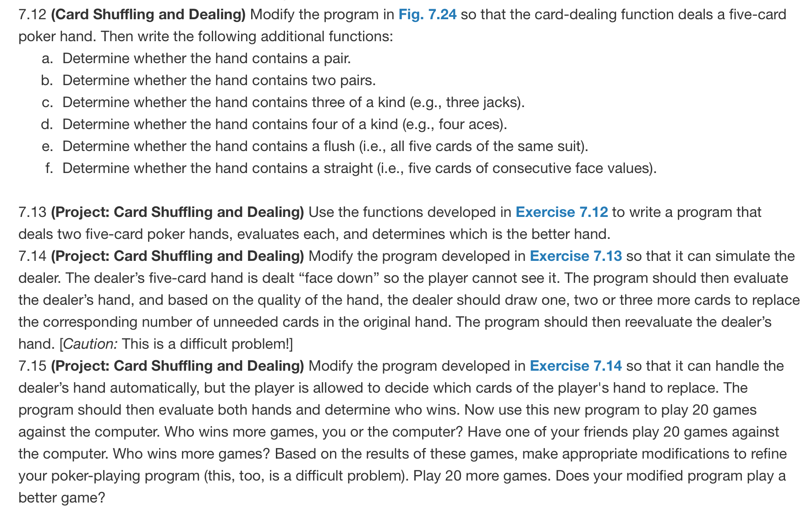

The main

Class Project:  
Write a poker game simulation using a structure and strings to define the cards as shown below (Fig. 10.3). Then write the following functions needed for a poker game.

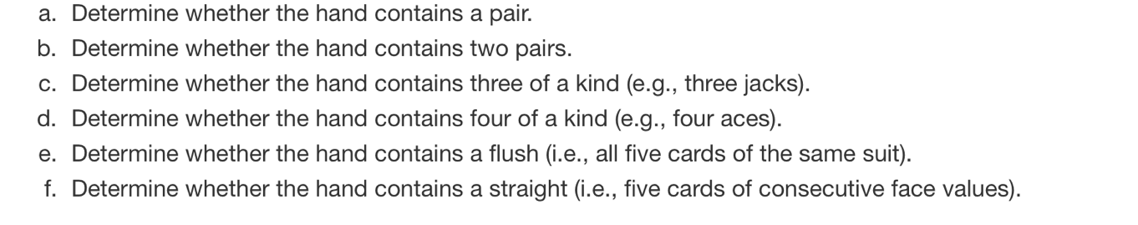

Also write a function that deals two five-card poker hands, evaluates each, and determines which is the better hand. Using pass by pointer technique, the function should provide the following information to main:

1. The two hands
2. Status of each hand (i.e. contains a pair or two pairs, …)
3. Determination of which hand is the better hand

The main program should play the poker game 100 times and store the result in an array. Also the same information needs to be stored in a file.

